MILESTONE ACADEMY
Holiday Assignment Class-II
Summer Vacation 2019-2020
Complete and submit on 18/06/19

Page 1 of 18

Q1. Can you find 13 parts of the body hidden in the maze below? They
are written upwards, downwards and across.
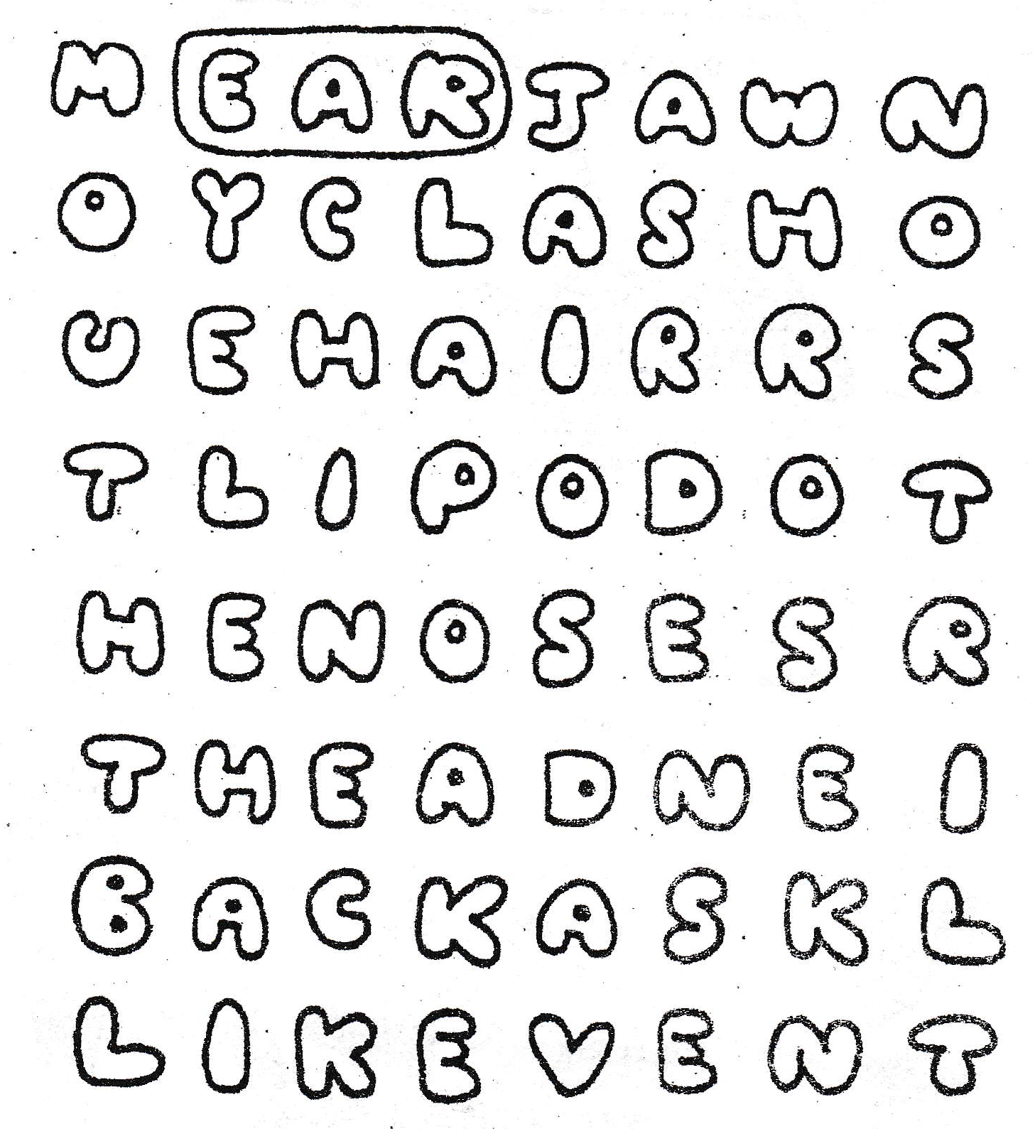

Page 2 of 18
Q2. Let’s find the treasure !!!!!!!!!!
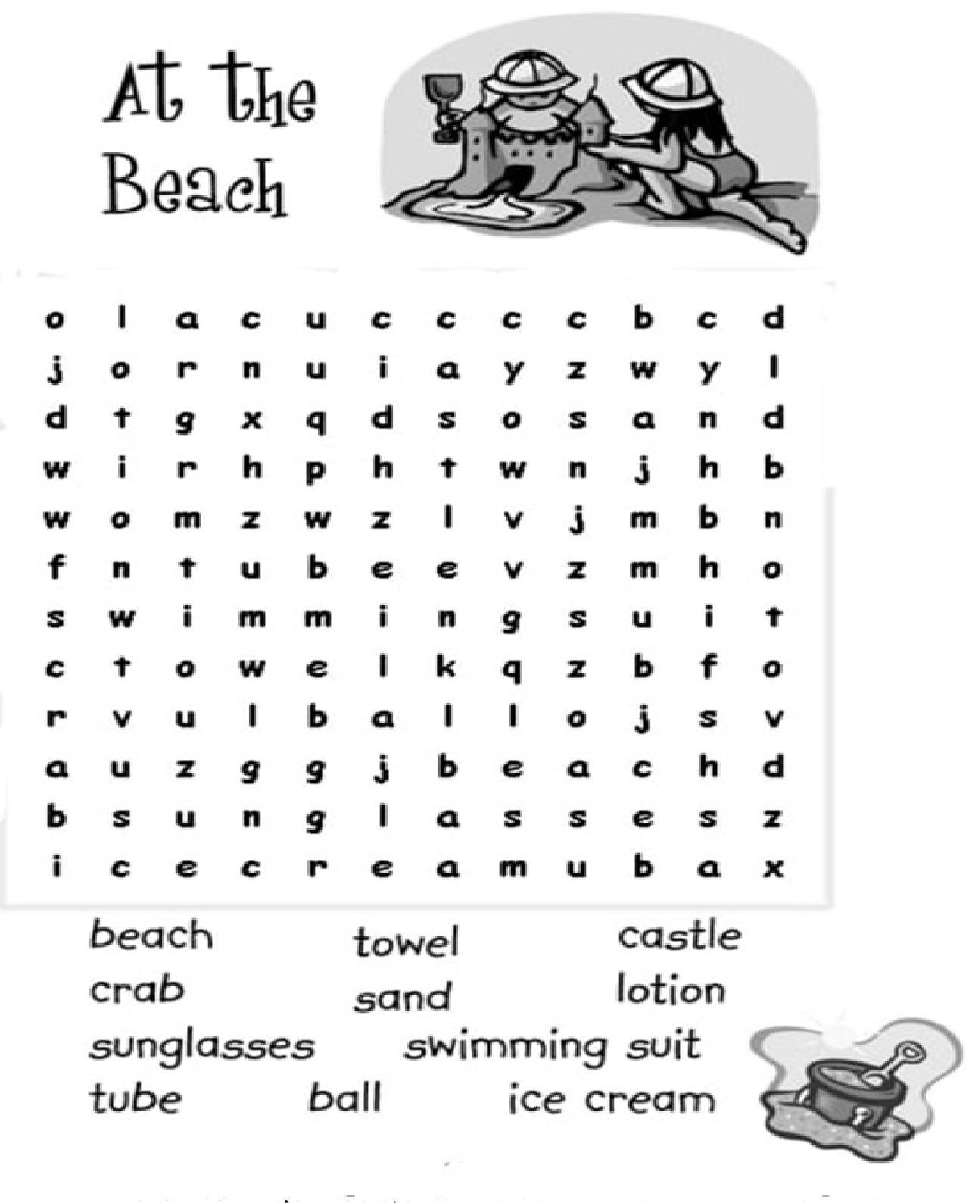

Page 3 of 18

Q3. Read the passage and answer the following questions:-
Burr! It is getting cold. Bear needs to get ready for winter. First, he eats a lot. Next, he finds a den. Then, he fills the den with leaves, so he will stay warm. Last, he eats even more! Is Bear ready for winter? Yes, he is. Winter is here!
1. What does the Bear need to do?

Ans.________________________________________________

2. How does the Bear get ready for winter?

Ans._____________________________________________________

_____________________________________________________

3. Write two ‘naming words’ from the passage.

a) __________________________ b)________________________

4. Pick any two ‘doing words’ from the passage.

a) __________________________ b) ________________________

5. Give two ‘describing words’ for:

bear - ___________________ , ________________________

Page 4 of 18

Q4. Unscramble the following words and match them with the right
image.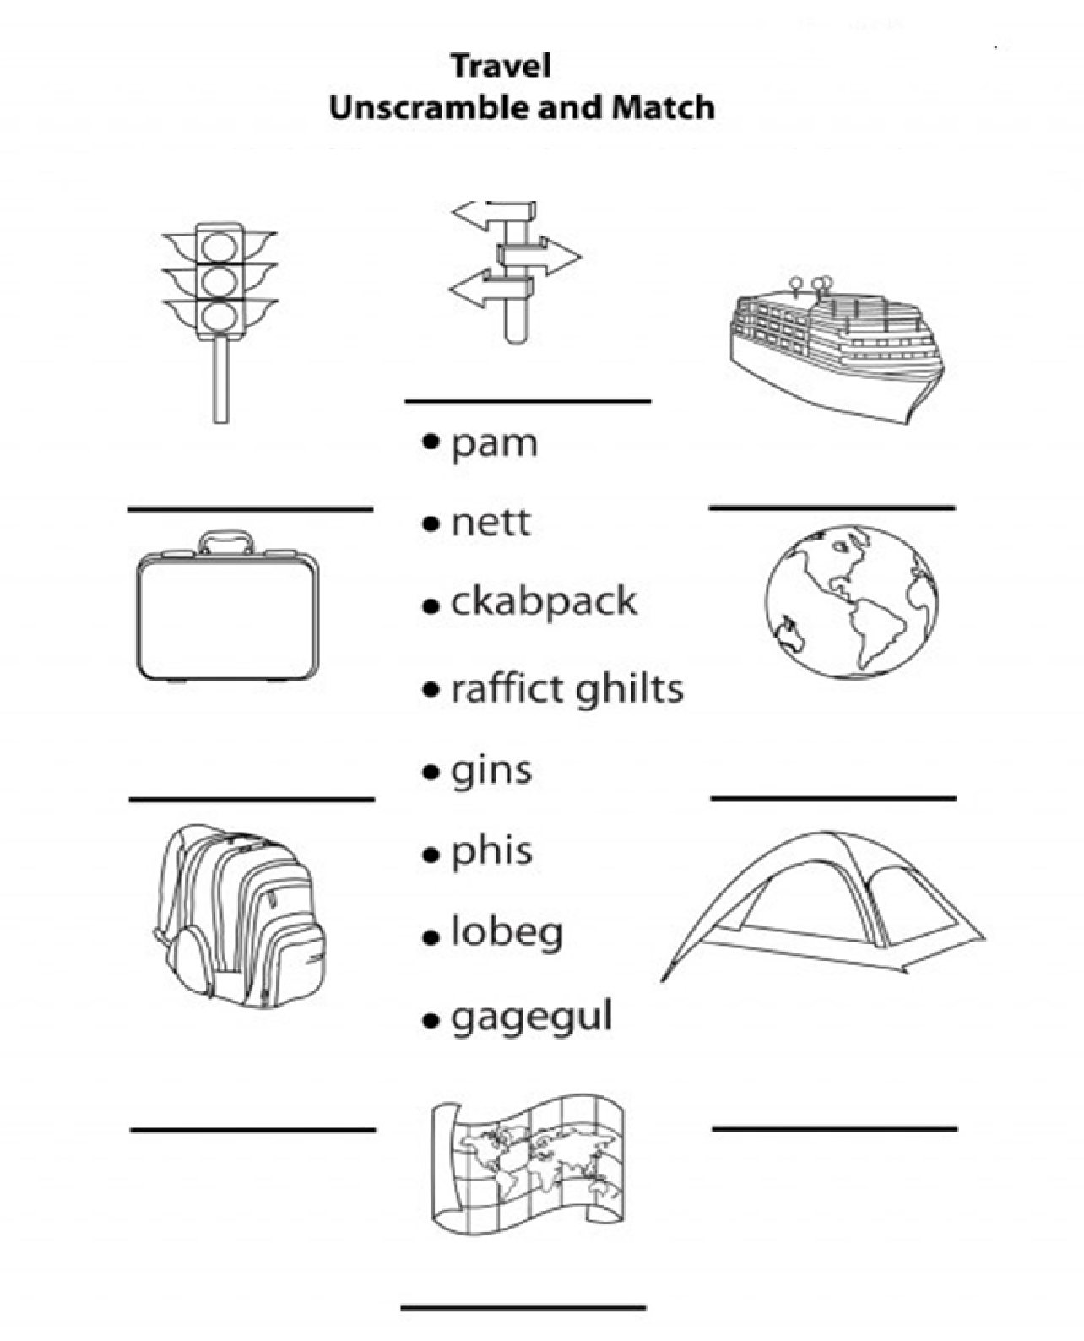

Page 5 of 18

Q5. Collect five different types of leaves and paste them on a separate
sheet . Write the names of the plants and the kind of the plant (tree,
herb, shrub, creeper etc.).

Q6. Do you know that the lines of the hand prints of different people are
different. Police use this to catch the thieves. Take thumb marks of
your two friends on a separate sheet and notice the differences.

Q7. a. It takes one year for the earth to go round the sun. Can you
guess how many times it has gone round the sun since you were
born?
Ans……………………………………………………………………….…………………………………………………………………………………………………………………………………………………………………

b. During the day white clouds appear in the sky in different
shapes. Look at the sky today and imagine the shapes of the
clouds this morning and evening, e.g.a ship, a flying bird,
someone’s face. Observe the sky and write your answer below.
Ans……………………………………………………………………….……………………………………………………………………………………………………………………………………………………………………………………………………………………………………………………………………………………………………………………………………………………………………………………………………………………………………………………………………………...

Page 6of 18

Q8. Share your experiences on.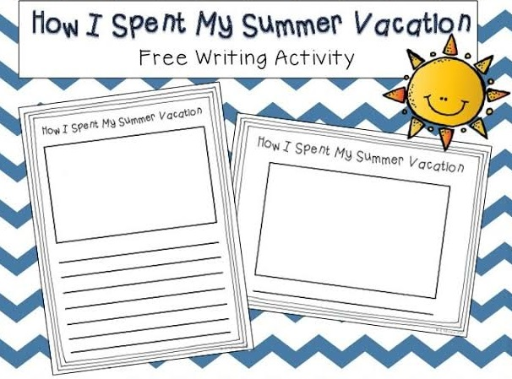

Page 7of 18

Q9. Skip count by 10 and fill the missing numbers:

10 | 20 |  |  |  |  |  |  |  | 100
110 |  |  |  |  |  |  |  |  | 200
210
310
410
510
610
710
810
910 |  |  |  |  |  |  |  |  | 1000

Page 8of 18

Q10. Fun with colours:-
See the colour code given in the box on the left hand side of the
drawing and colour accordingly.

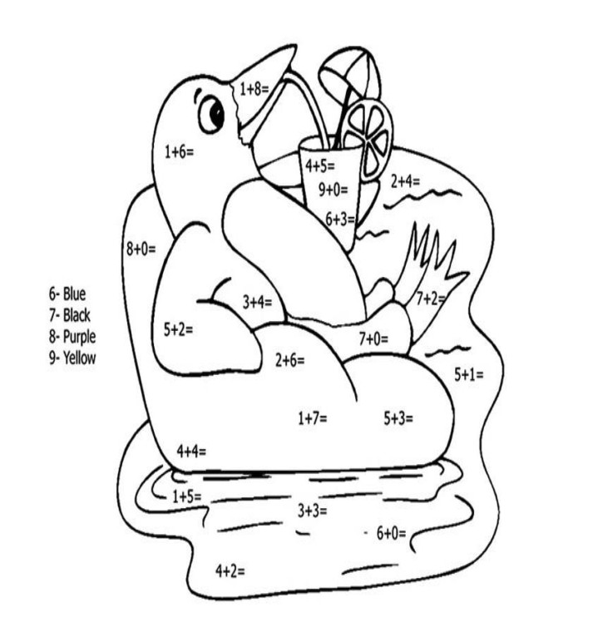

Page 9of 18

Q11.Write down five similarities and five differences between M.S
Dhoni and Virat Kohli.
Ans- SIMILARITIES
1. ………………………………………………………………….......
2.………………………………………………………………………
3.………………………………………………………………………
4.………………………………………………………………………
5.………………………………………………………………………

DIFFERENCES

- ………………………………………………………………………
- ………………………………………………………………………
- ………………………………………………………………………
- ………………………………………………………………………
- ………………………………………………………………………

Page 10 of 18

Q12. A) Learn multiplication tables of 2 to 10 and fill in the grid.
X | 1 | 2 | 3 | 4 | 5 | 6 | 7 | 8 | 9 | 10
1
2
3
4 | 4
5
6
7 |  |  |  |  | 35
8
9 |  |  |  |  |  |  |  |  | 81
10

B) Select 5 objects and draw their front view, sideview& top
view on an A-4 size paper.
C) Learn to see the time in the clock.
D) Tell what is the time shown in the following clocks?
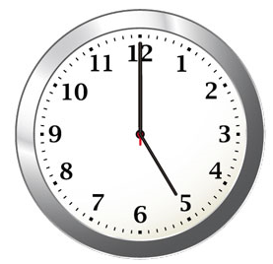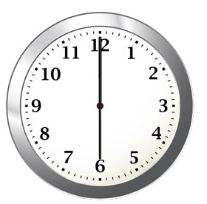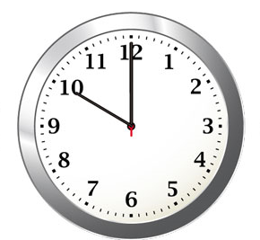
__________________ __________________ __________________

Page 11of 18

Q13. 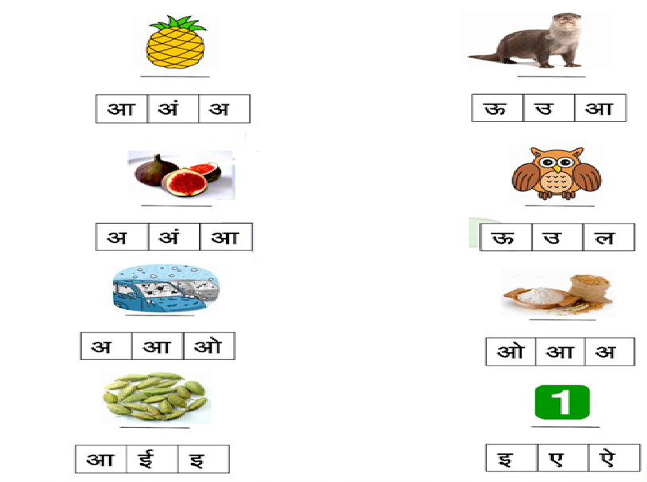

Page 12of 18

Q14. खाली स्थान भरो :-
क |  |  | घ
च |  |  | झ
ट
 | थ
प |  |  |  | म
य
श
क्ष |  | ज्ञ

Page 13of 18

Q15. चित्र देखकर वाक्य लिखिए :-
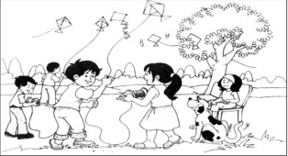

____________________________________________________________________________________________________________________________________________________________________________________________________________________________________________________________________________________________________________________________________________________________________________________________________________________________________________________________________________________________________________________________________________________________________________________________________________________________________________________________________________________________________________________________________________________________________________________________________________

Page 14of 18
Q16. मिलान करो:-
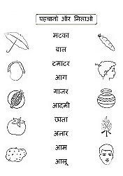

Page 15of 18

Q17. वर्ग पहेली :-

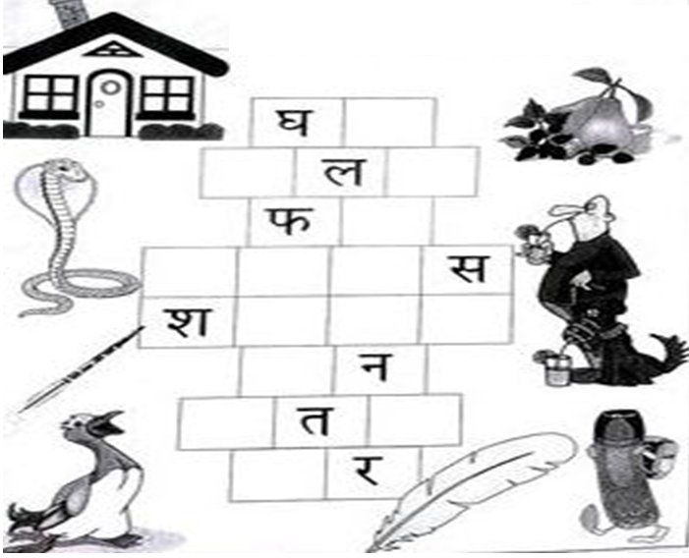

Page 16of 18

Q18. दिए गए अक्षरों मे सभी मात्राऐं लगाये. आपके लिए एक उदाहरण दिया हुआ है :-
क | का | कि | की | कु | कू | के | कै | को | कौ | कं | क:
त
प
ख
ज
न
द
म
स

Page 17of 18

In Your Daily Routine of Summer Vacation Remember 5 Points
